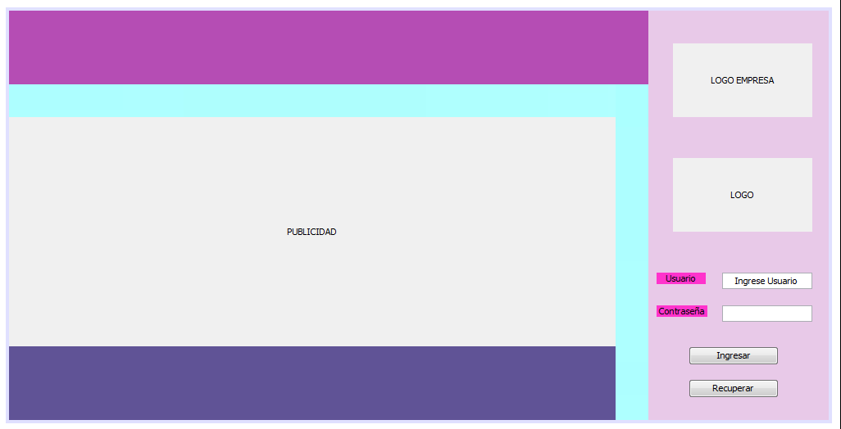

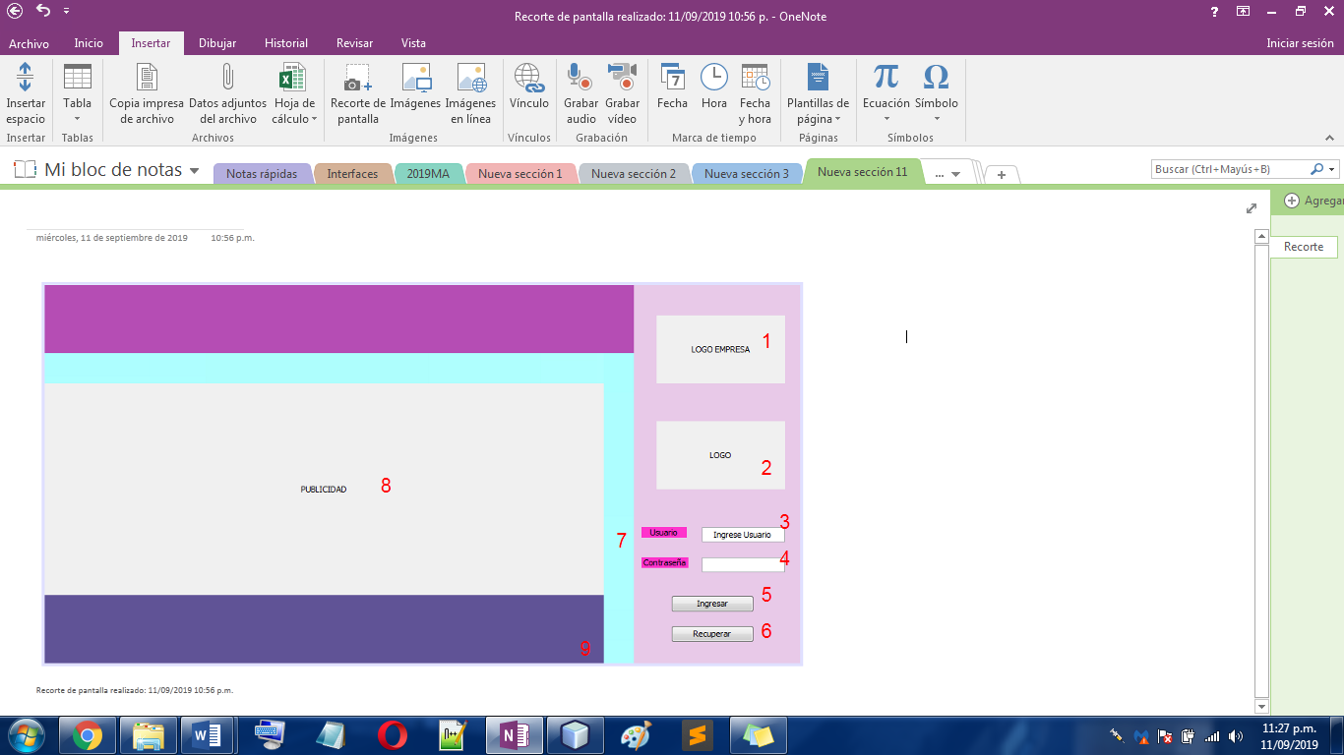

|  |  |
| --- | --- |
| Componente | Numero |
| jLabel_LogoEmp | 1 |
| jLabel_Logo | 2 |
| txt_IngreseUsu | 3 |
| jPass_Contrasenia | 4 |
| btn_Ingresar | 5 |
| btn_Recuperar | 6 |
| jLabel_Contrasenia | 7 |
| jLabel_Usuario | 7 |
| jLabel_Publicidad | 8 |